Stella Kemp   
  
April 4 2025   
  
CSD 340 Web and HTML Development  
  
Darren Osier   
  
  
  
  
  
  
  
  
  
About me Page:   
  
Sam Hancock , 29, Network Engineer : Cloud Infrastructure. Born in Al, moved to Washington DC. Pet lover, Part time gig on Rover, By day, Sam thrives in the complex world of network architecture. His analytical mindset and problem-solving abilities have accelerated his career trajectory, earning him recognition from a security analyst to his current role in the Network team! Beyond his professional life, Sam is an avid rock climber who can often be found at the Bouldering Project in the district. This passion for climbing developed during the pandemic has since become a cornerstone of his identity. As a committed vegetarian for the last year Sam approaches nutrition with new attention to detail. It’s important to eat well before a climbing session or he will feel too weak to stay on the wall for a long time. Sam's love for animals extends beyond his dietary choices. He regularly volunteers as a pet sitter through Rover, turning his affection for animals into a rewarding side gig that brings joy and companionship into his life. When not working, climbing, or caring for pets, Sam unwinds with books on adventure and technology, and enjoys occasional morning jogs along the Potomac River—a practice that helps clear his mind before diving into complex network architectures.

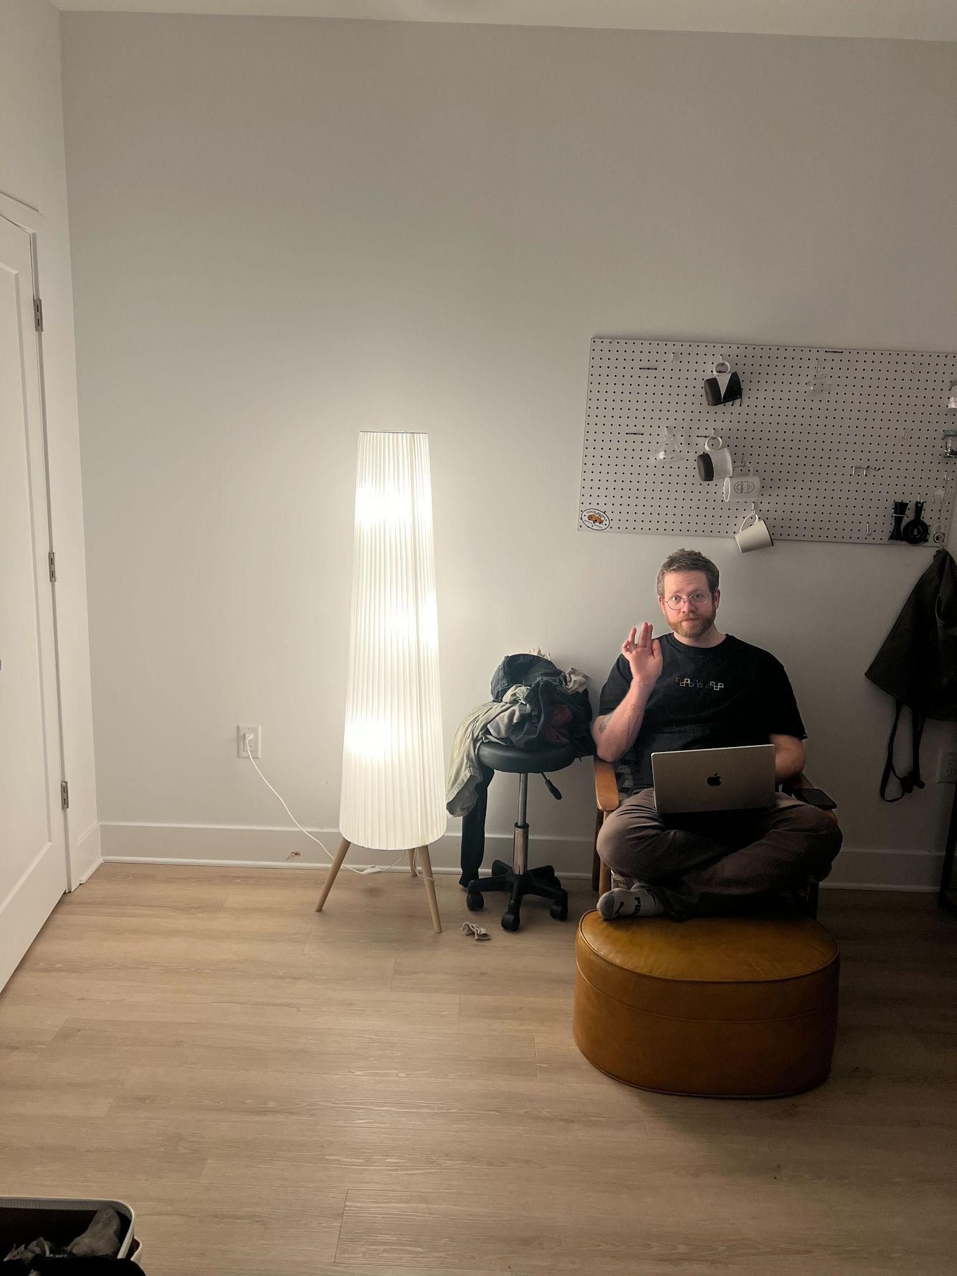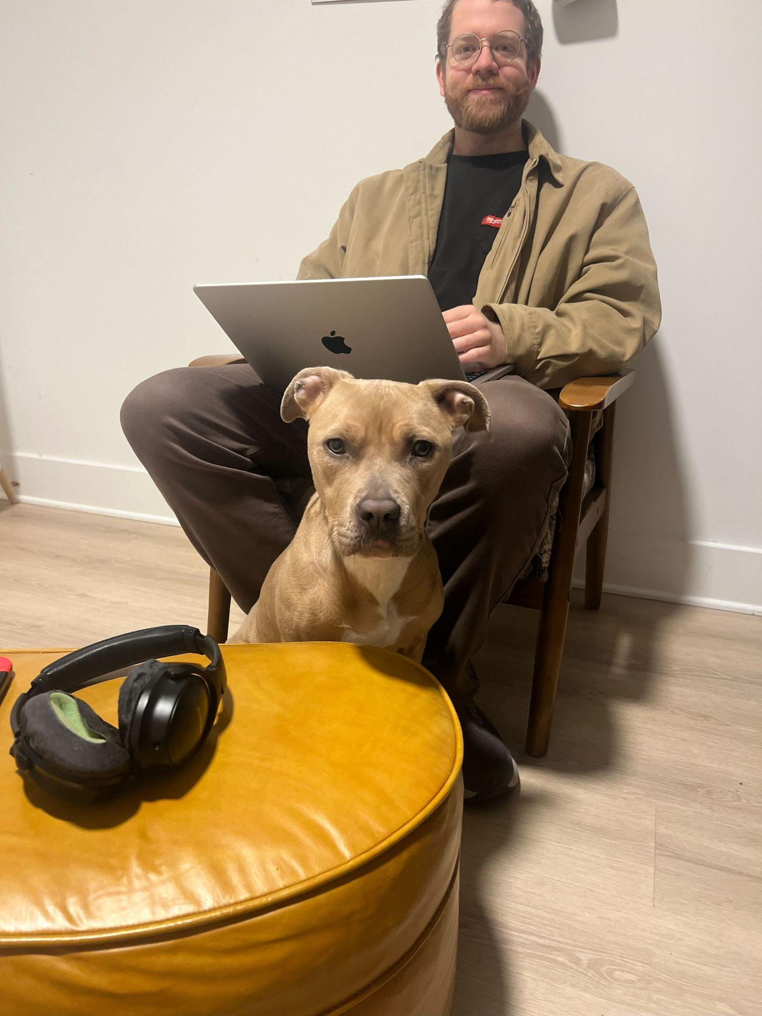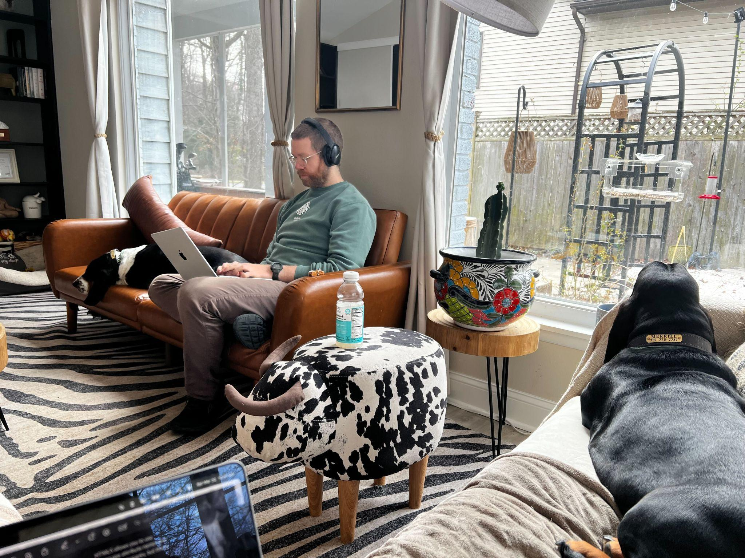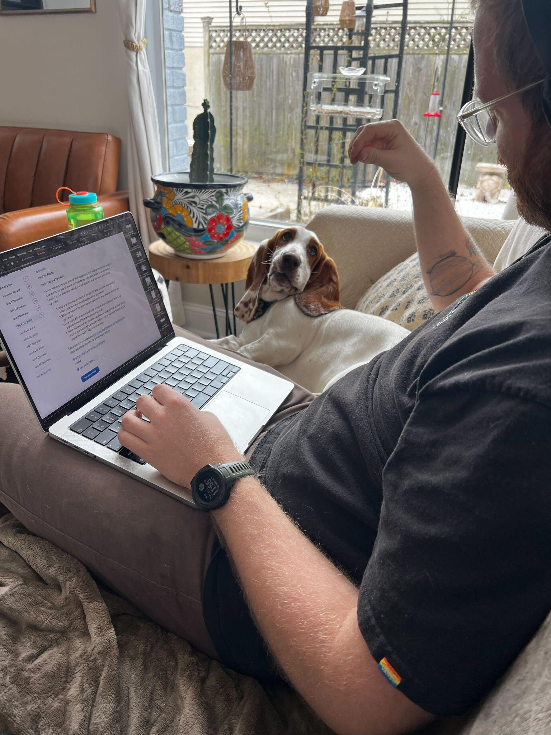

Hobbies page   
Interview :

**Me:** How did you first get into rock climbing?

**Sam:** I started climbing about seven years ago when a friend took me to an indoor gym. I was immediately hooked by the problem-solving aspect and the physical challenge. Within a few months, I was heading outdoors whenever possible to climb real rock. There's something incredibly fulfilling about the connection with nature and the mental focus required.

**Me:** As a vegetarian, how do you fuel your body for such a physically demanding activity?

**Sam:** Great question. Protein is obviously important for climbing, so I focus on plant-based proteins like lentils, chickpeas, tofu, and tempeh. Lots of beans. I eat a lot of nutrient-dense foods—plenty of vegetables, whole grains, nuts, and seeds. On climbing days, I make sure to have good carb sources for sustained energy and pack portable snacks like homemade energy bars with nuts and dried fruits.

**Me::** Has your climbing influenced your eating habits, or was it the other way around?

**Sam:** They've definitely influenced each other. I was vegetarian before I started climbing, but climbing made me much more conscious about nutrition. I had to learn how to properly fuel my body for performance and recovery. If I want to climb for more than an hour I need to pay much more attention to my protein intake, timing of meals, and proper hydration than I did before just working out in a weight room.

**Me::** You're also an avid reader. What kinds of books do you enjoy?

**Sam:** I love non-fiction, particularly books about adventure, mountaineering, and exploration. Jon Krakauer's "Into Thin Air" and Tommy Caldwell's "The Push" are favorites. But I also enjoy fiction that takes me to different worlds—science fiction and historical fiction especially.

**Me::** How do you balance your job with your various hobbies?

**Sam:** It's definitely a juggling act! I work as a software developer, which means long hours sitting at a desk. I've become very protective of my time and intentional about scheduling. Weekends are sacred for outdoor climbing trips. During weekdays, I climb at my local gym two evenings a week. I usually read before bed or during my lunch break. As for jogging, I try to get out for short runs twice a week, usually in the mornings before work.

**Me::** Does your work in software development connect with your outdoor activities in any way?

**Sam:** Absolutely. Sitting at a computer all day creates a strong desire to get outside and move my body. But there are also some interesting parallels between coding and climbing—both involve problem-solving, patience, and working through challenges methodically. The logical thinking I use at work helps me approach climbing routes analytically, while climbing teaches me persistence that I bring back to difficult coding problems.

**Me::** How does jogging fit into your fitness regime alongside climbing?

**Sam:** Jogging provides complementary cardio fitness that climbing doesn't always deliver. Rock climbing is more about strength, flexibility, and power. Adding regular runs helps with my overall endurance, which is crucial for longer climbing routes. It's also meditative for me—a chance to clear my head and process thoughts with simple, rhythmic movement.

**Me:**Has being vegetarian presented any challenges when you're on climbing trips or traveling to remote areas?

**Sam:** It definitely requires more planning! I research food options before trips and often pack extra supplies. Remote climbing destinations can have limited vegetarian options, so I'll bring protein powder, nuts, and shelf-stable foods. I've become pretty good at cooking simple, nutritious meals on a camping stove. The climbing community is generally quite accommodating—many climbers are health-conscious and eat plant-based diets themselves.

**Me::** What does a typical day look like for you when balancing all these different interests?

**Sam:** On workdays, I might get up at 6am for a quick 30-minute jog, then work from 8 to 5. If it's a climbing day, I'll head to the gym for a two-hour session, otherwise I might read for an hour or catch up with friends. Weekends look completely different—often camping near climbing areas, waking up at dawn to get on the rock before it gets hot, climbing until afternoon, then relaxing with a book at camp in the evening. Food prep happens on Sundays, preparing healthy meals for the workweek.

**Me:** What advice would you give to someone interested in adopting a similar lifestyle—balancing outdoor activities, reading, and a vegetarian diet?

**Sam:** Start small and be patient with yourself. You don't need to transform your life overnight. Maybe begin with one or two vegetarian days per week, or start climbing at a gym before heading outdoors. Protect your hands and stretch. Most importantly, find joy in the process of working out rather than treating these as obligations. When activities bring genuine happiness, finding time for them becomes natural rather than forced. And connect with communities or people they'll provide friendship that makes everything more sustainable.

Landing Page color scheme:

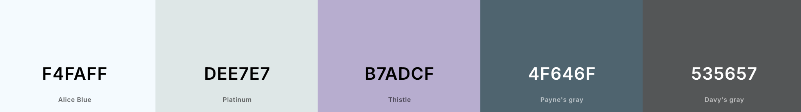

* Front-end Style Guide: 535657 4F646F B7ADCF DEE7E7 F4FAFF